**Challenge:**

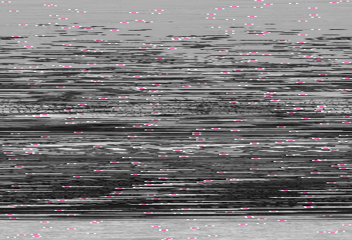

Unscramble the image to read the flag!

**Hints:**

* Ask the participants to see if they can find patterns in the scrambled image and what they could mean
* The name of the challenge is a clue!

**Reasoning:**

On each row of the image the sequence of colours White, white, white, pink, pink, pink, pink, pink, pink, white, white, white occurs at a random location along the row. This sequence of colours is how far the row of the image has been offset from the side of the image, hence the name “Sidewinder”. A Sidewinder is also a snake which suggests the use of python is required, which it is

**Solution:**



ltdh19{python_is_a_weapon}

**Walkthrough:**

To complete the challenge the participant must write a script that can identify the pixel sequence 3x White 6x pink 3x white and then offset it by the amount required to make the pixel sequence flush with the side of the image as shown in the solution. This will then reveal the image.

Github link of descramble code

**Assistant directions:**

If the participant has no idea what to-do then suggest the two hints stated above

If the participant has an idea what to does but has little to no experience with image manipulation in python then refer then to the PILLOW cheat sheet

If the participant still wants more information on how to use PILLOW then refer then to the online docs here https://pillow.readthedocs.io/en/5.3.x/ (just google “python PIL”)